Question B:

-- (i) Write a CTE 'Histogram' that counts the number of loans for each risk score.

--Write a simple query to display the results of the CTE in descending order of the count.

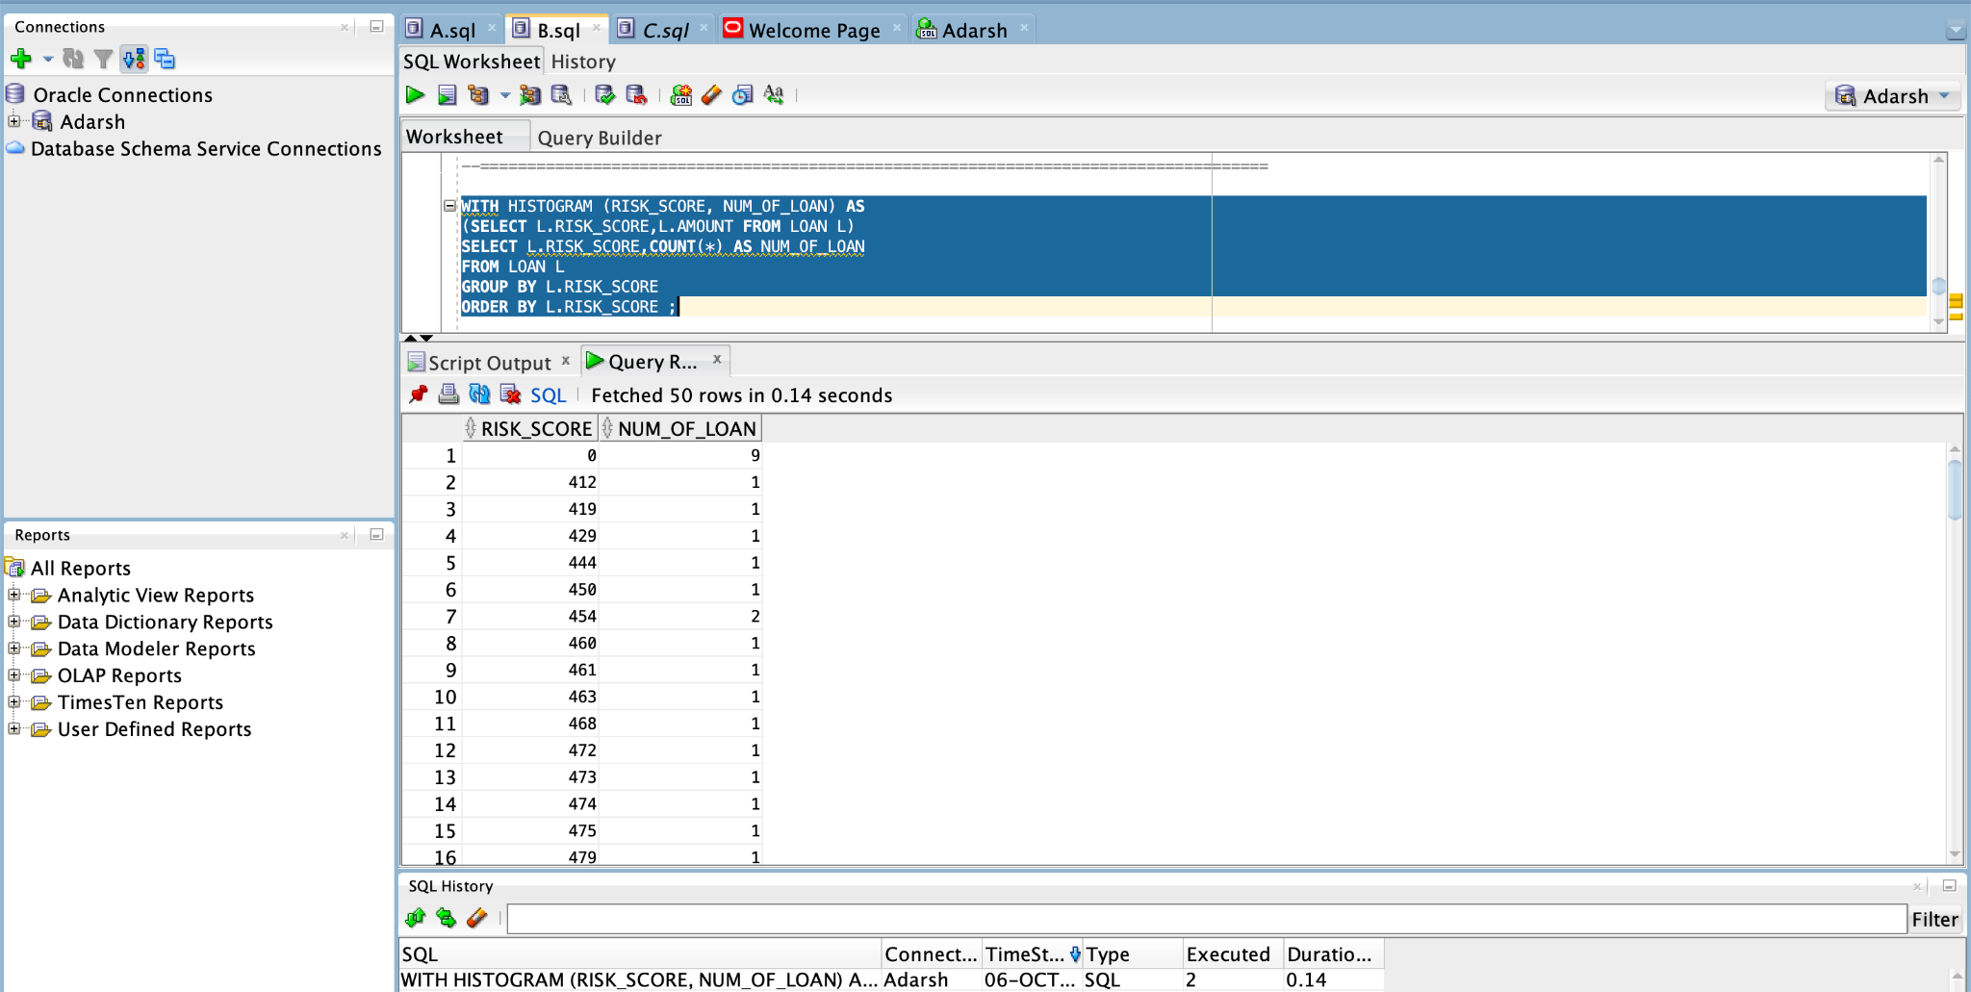

================================================================================================================================================

--(ii) Spot the risk score(s) with the minimum number of loans. Call this CTE as RiskScoresWithMinLoans.

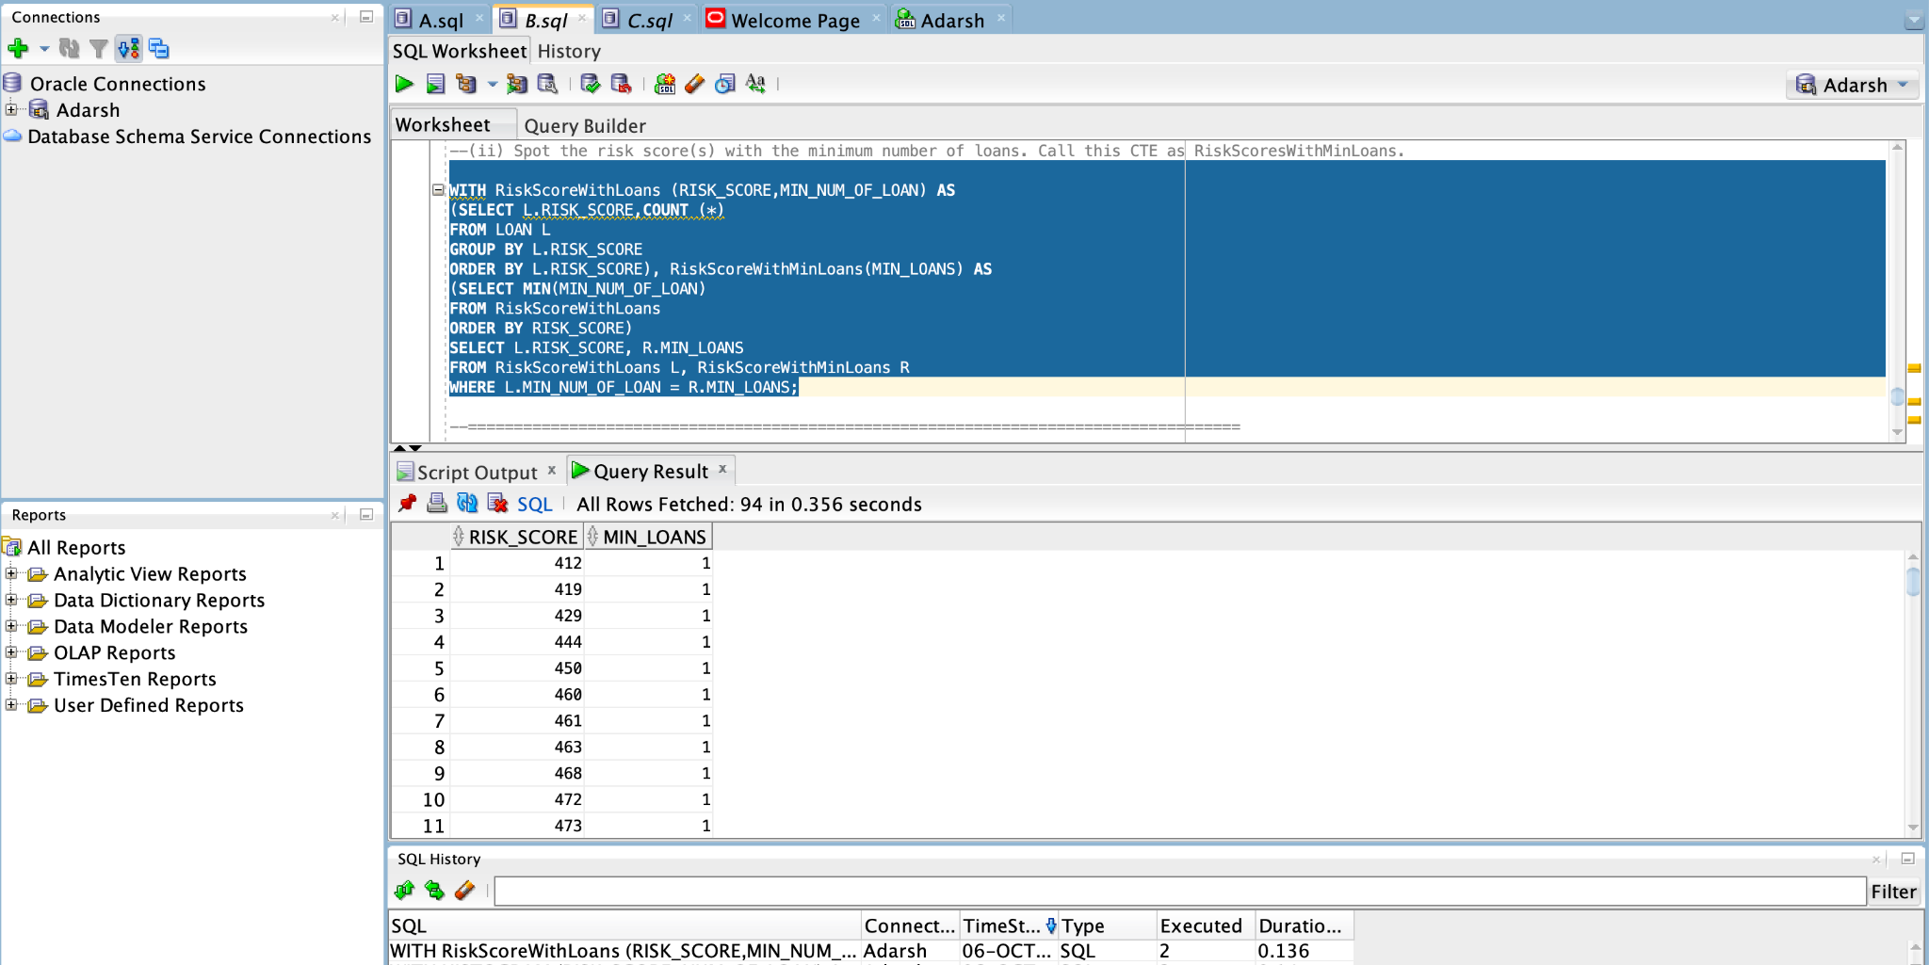

--(iii) Using your Histogram and RiskScoresWithMinLoans CTE,

--write a SQL query to find a description of loans which have a risk score spotted in (ii).

